TASK NO-1

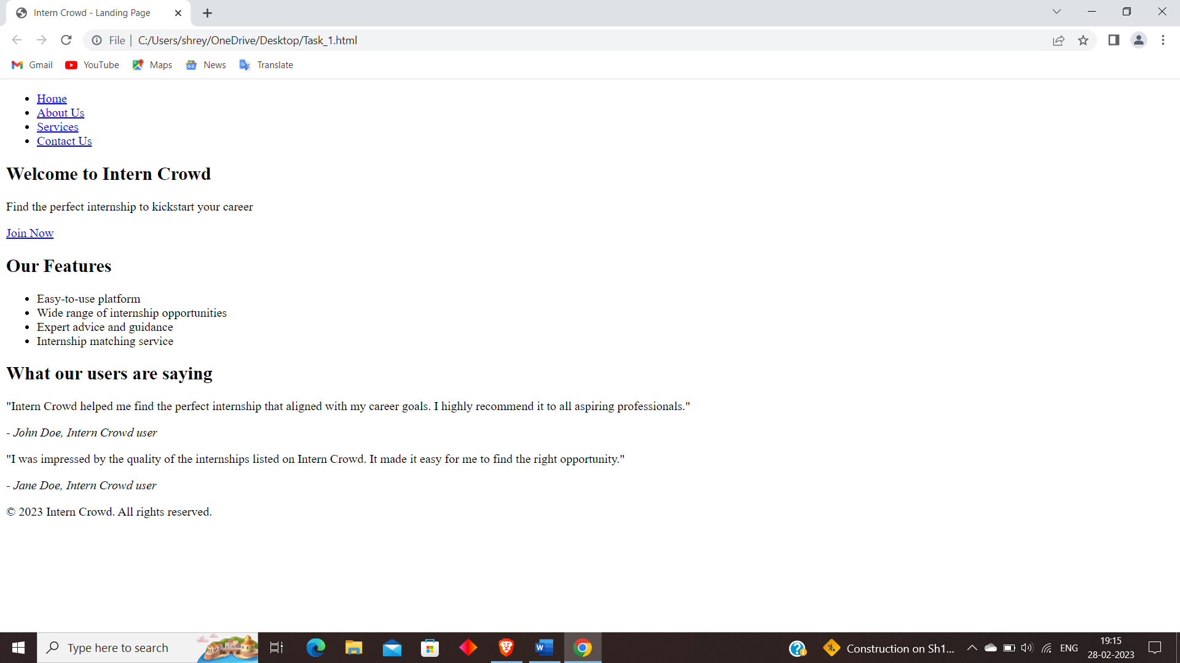

<!DOCTYPE html>

<html>

<head>

<title>Intern Crowd - Landing Page</title>

<link rel="stylesheet" href="style.css">

</head>

<body>

<header>

<nav>

<ul>

<li><a href="#">Home</a></li>

<li><a href="#">About Us</a></li>

<li><a href="#">Services</a></li>

<li><a href="#">Contact Us</a></li>

</ul>

</nav>

</header>

<main>

<section class="hero">

<h1>Welcome to Intern Crowd</h1>

<p>Find the perfect internship to kickstart your career</p>

<a href="#" class="cta">Join Now</a>

</section>

<section class="features">

<h2>Our Features</h2>

<ul>

<li>Easy-to-use platform</li>

<li>Wide range of internship opportunities</li>

<li>Expert advice and guidance</li>

<li>Internship matching service</li>

</ul>

</section>

<section class="testimonials">

<h2>What our users are saying</h2>

<div class="testimonial">

<p>"Intern Crowd helped me find the perfect internship that aligned with my career goals. I highly recommend it to all aspiring professionals."</p>

<cite>- John Doe, Intern Crowd user</cite>

</div>

<div class="testimonial">

<p>"I was impressed by the quality of the internships listed on Intern Crowd. It made it easy for me to find the right opportunity."</p>

<cite>- Jane Doe, Intern Crowd user</cite>

</div>

</section>

</main>

<footer>

<p>&copy; 2023 Intern Crowd. All rights reserved.</p>

</footer>

</body>

</html>